Skyping with author Don Gillmor
June 14, 2012.
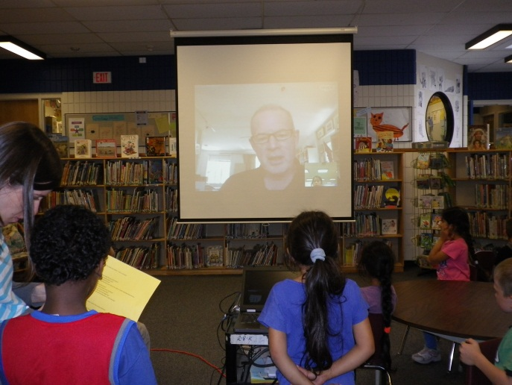
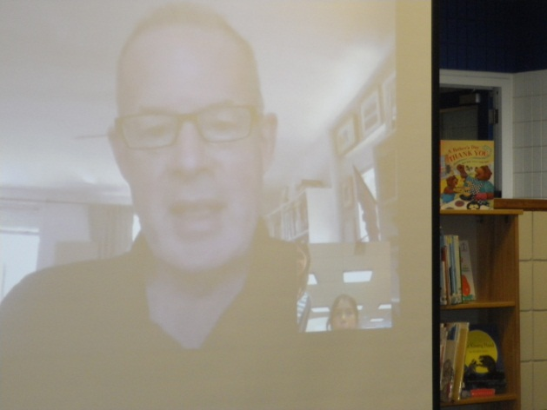
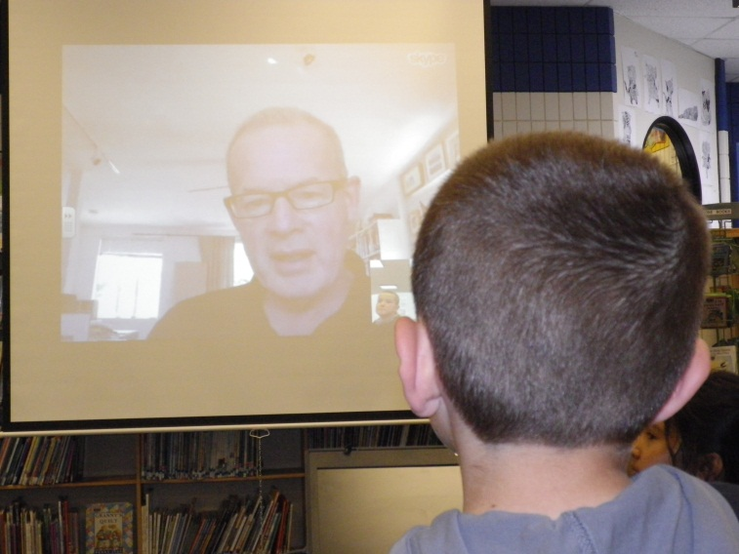
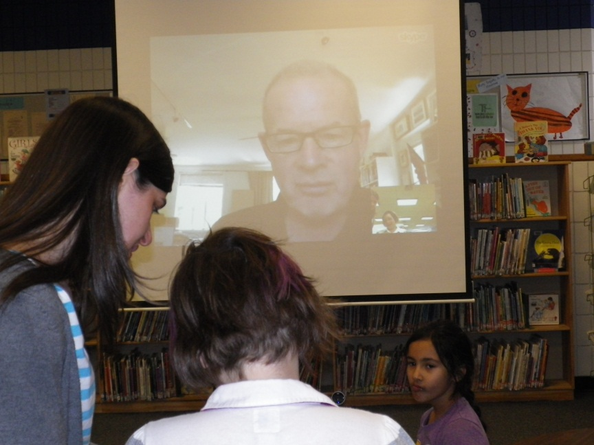
The class of 2/3 Rz talked to Don Gillmor about his book Yuck, A Love Story that was illustrated by Marie Louise Gay. We asked him a lot of questions and found out a lot about the book.

