Racism

1: Racism is how people act when they don't think that form of change does
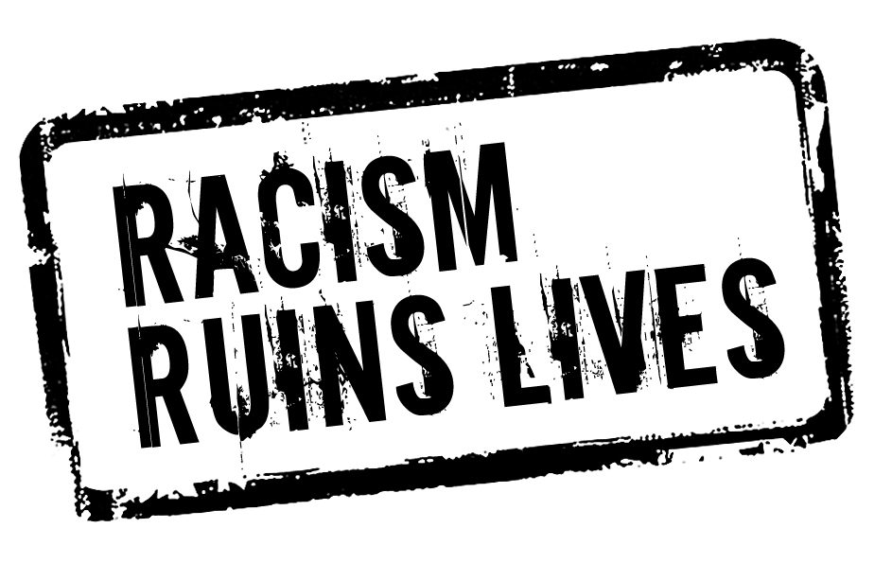
not fit that person and how they want their world to be. I also learned that it hurts people and makes them feel like they are not as important as that person.

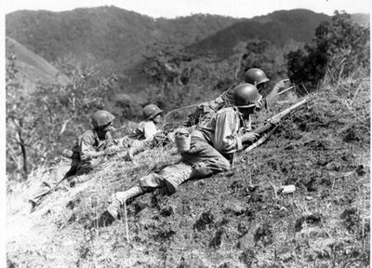
2:Racism is a conflict because it starts wars; for example, when someone say this person is bad or did something wrong, then stereotyping that all black people ( or another culture)are bad because of this action ...then this is what can happen
3:when someone hates you for doing something better than them or if they are a different race or color or if you speak a different language, they will hate you and that's what builds up fights.
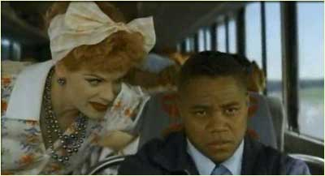
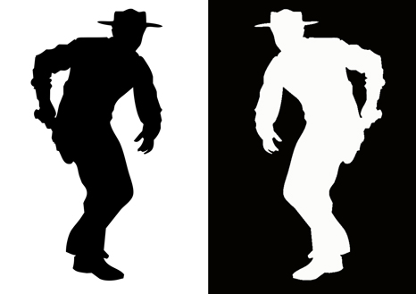
By:Vennessa

