Racism as a Conflict and as a Form of Bullying

- Racism is when people or groups of people discriminate other
groups of people by different races, ethnic background, physical appearance, etc.

- What I learned about racism is that racism is a conflict,
for everyone. It can lead to killing, murders and other horrible actions. Racism is also hatred. Also, racism can happen any where, any time, and to anybody.

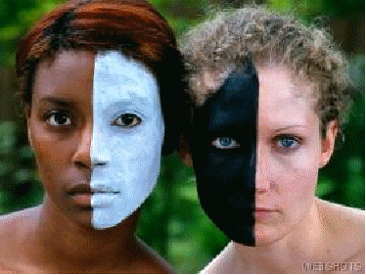
- Racism is like bullying because they both relate to hurting the
person and of hatred. They are both horrible things, but we
cant stop it.

By: Rabia 7-2

