Racism
What Does Racism Mean?
Racism is when you have deep hate for a different race,culture,religion someone who looks different then you with different features.
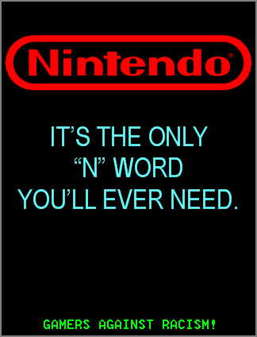
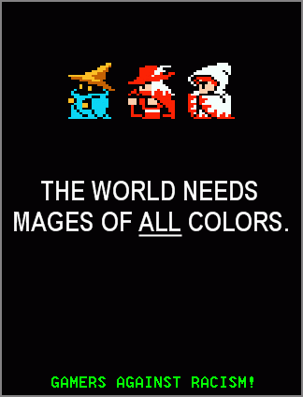
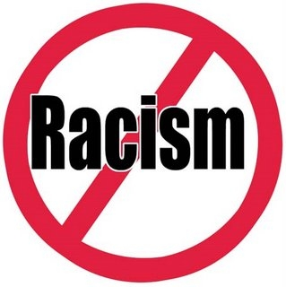
Whats Did You Learn So Far About Racism?
I have learned that racism can cripple people and that our world was once split in half .One side thinking they were better than others and the other half been beaten and put to work through harsh weather. Now that the world is coming together there have been more smiles than frowns and more happiness than sadness.
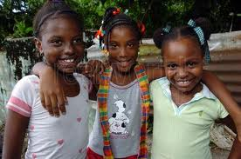

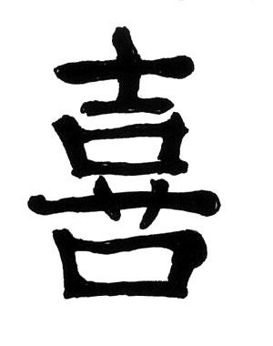


How Is Racism A Conflict?
It is a conflict because it creates bullying,world distress,war,anger and sadness.
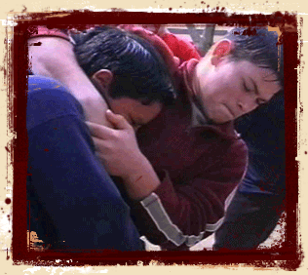

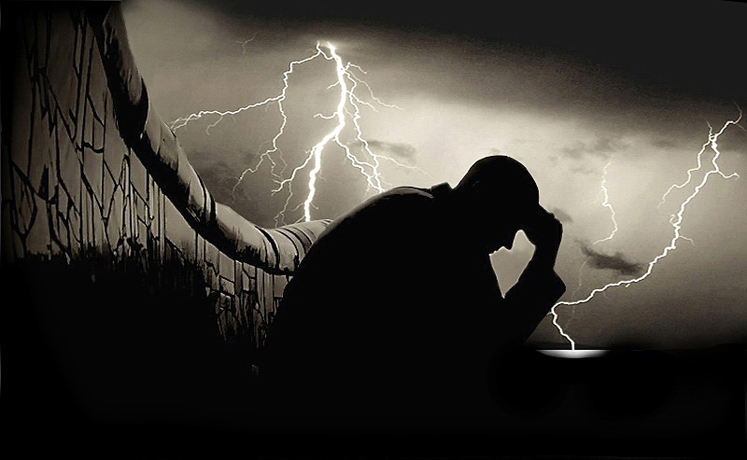
How Is Racism A Form Of Bullying?
Racism is a form of bullying because one person from one race could see something on the news about racism then bully someone that is different than them.

By. Aaliyah

