My Poem
Poem title: Who I am

Who I am, is who I want to be
and no man on earth, can change me;
they disqualify me for the color of my skin
and do not appreciate me as a real person;
although I have the same red blood
they do not let me speak my mind;
and their reasons, I don't understand,
they think I am different because I am BLACK!
But they don't comprehend that I am also a HUMAN.
God gave me a brain to understand; he gave me a heart to feel,
he also gave them the same.
yet I question myself , am I still not the same?
for years to come, the hatred will be,
and no one will surrender from being mean.
Believing that things can get better
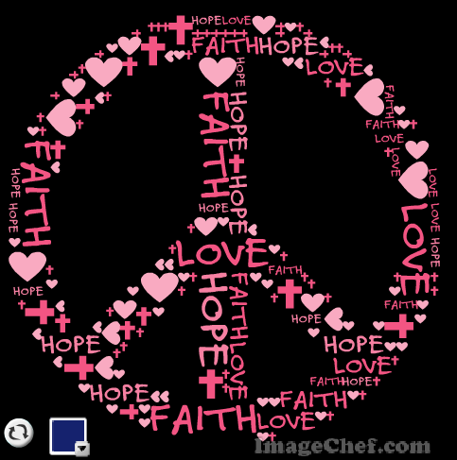
the things we do and say, actually matters!
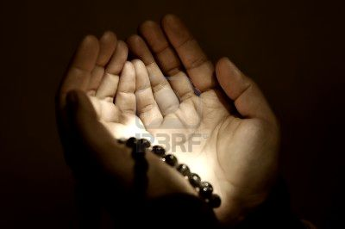
by: Sara

