RACISM

- I think Racism is when you hate a person belonging to a specific race, culture, color or religion. For example, when you hate or judge a culture or race because of what one person did.

  - It begins with stereotyping which generates hatred, that can turn into fights and wars.
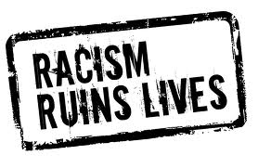
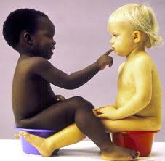
This is how it should be.

