Racism

1.Racism is when two people make mean and hurtful comments about each other. What I've learned so far is that racism can come from girls and boys and can ruin good friendships.

2.I see racism as a conflict because it starts wars and or fights.
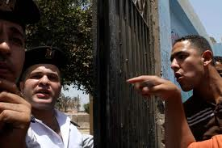

3.Racism is bullying because it can cause teasing, fighting, arguing and oppression.

