Some Thoughts on Racism from a Quote and from Classmates

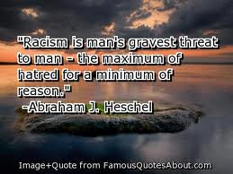
“It would be good for humanity if we could eliminate racism.'' By anon classmate

“What’s the point in fighting with each other, we’re all people'' by Landon

“We think that without racism the world will be a better place'' by Caleb and Sami

By Caleb and Sami interviewing some classmates in 7-2 and selecting a few to share.

