Thoughts About Racism
We’re all different. We all have different shapes and sizes. It's amazing but it doesn't matter because the world still has racism. Even though we’re trying to fight it, we can't sometimes; there's always a conflict, no matter how hard we try but the world can have peace. Peace doesn't mean living in a place where there's no war, conflict and equal rights. We all want different things. Racism is hate but we’re not all hating each other. It should be excluded. We can all work together and make a difference by having less conflict, less war and more equal rights! It's amazing to see all citizens working together and accomplishing dreams and hope for the world.

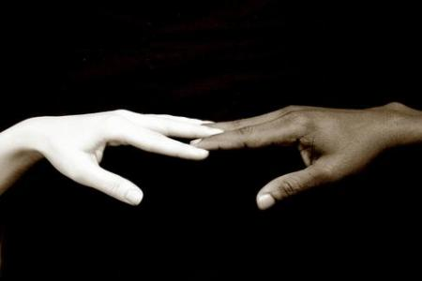
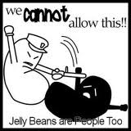
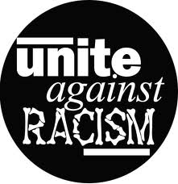
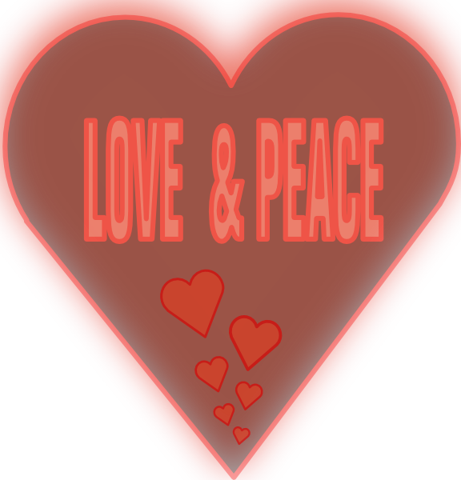
All United

By Aaliyah 7-2

