Roland Cilliers Jan 26, 2013 - 11:49 AM
Parry Sound Beacon Star, North Star & Lifestyles This Weeky

A more relevant class for girls
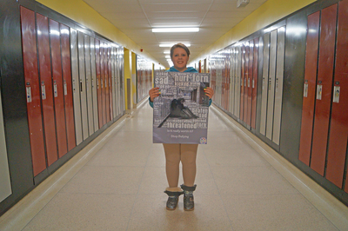
Relevance project. Brookelyn Madigan is among the students taking advantage of the Relevance Project, a unique high school program tailored to female students at risk. Roland Cilliers
PARRY SOUND – The average class just isn’t relevant for some Parry Sound High School students.
The kinds of skills they need to thrive in their day-to-day environment are generally not covered in algebra. To address this, there’s a new class currently offered to only a select few at the high school that aims to empower young women who may be having a few issues with the usual class offerings.
The Relevance Project, currently kicking off its third semester in operation, is a two-credit course aimed at girls in Grade 9 and 10 who have significant truancy issues. The class size is small, at no more than 12 students, and features a weekly mental health counseling component.
Jennifer Norton, who teaches the class, said she has seen remarkable results from the enrolled students.
“My personal goal for the program is to empower the girls to be successful and want to come to school every day,” said Norton. “I would like to see the class offered beyond the funding commitment as a vital resource for females at PSHS. We are already seeing a positive influence from the program in accomplishments as the girls are now taking leadership roles in the school and their community on their own initiative. We are already seeing results from the program.”
Norton spoke at the Near North District School Board meeting on Tuesday to showcase the successes shown through the class and to make the argument for the continued funding of the program. At this point, Norton has received funding to run the program for only four semesters.
Students in the relevance class have access to several technological bonuses that many students don’t.
“The program has purchased iPads used exclusively in our class to enhance the learning experience and encourage students to come to class. The program is utilizing cutting edge technology to remain current and relevant to the students,” Norton said.
What really sets the class apart from others in the school is the way it encourages students to lead their own projects. Currently, the class is spearheading a bullying campaign designed to educate and inform fellow students on the effects of bullying.
Brookelyn Madigan, a Grade 10 student of the class, said the program has very much improved her enjoyment of school.
“I have always wanted to do something to make a difference and help people,” said Madigan. “With this class, the bullying campaign and raising money for the SPCA, I’ve been able to do more things and I’m now thinking about joining the school committee next year because that’s something that I like doing now.”
The bullying campaign grew from a class discussion and has led to a survey on bullying, posters, pamphlets and a plan for the upcoming pink shirt day.
“When the bullying week came up we were sitting around talking, and we thought it would be interesting to do a survey, and the next two weeks we were plannign the survey and then two weeks after that we were sending it out,” Madigan said. “All of a sudden it got really cool, and I was excited to be in this class at that time because I felt I was making a differance in our community and school.”

