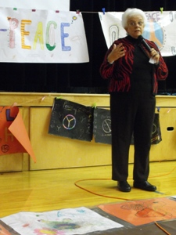
Linda Hooper

Linda Hooper,former Principal of Whitwell Middle school and star of the emmy nominated Paper Clips movie addressed students and staff at Greenfield Elementary school in Cape Breton. She was in the area to promote the first Nova Scotia Provincial Holocaust Education Week.

