Happiness/Resiliency Mind map

Introduction
When it comes to living a happy and successful life, it essentially boils down to a few key common factors that one must work on in order to be rounded, grounded and happy. These key factors – as shown within the mind map – will ensure that you stay centered and focused on what is most important in your life, while making sure that life never gets the better of you. Stick with them, cultivate them and keep them at the forefront of your mind on a daily basis – at home and at work – and happiness will no doubt find you around every corner no matter how grim life may appear to be in the fleeting moment.

A Happy Body
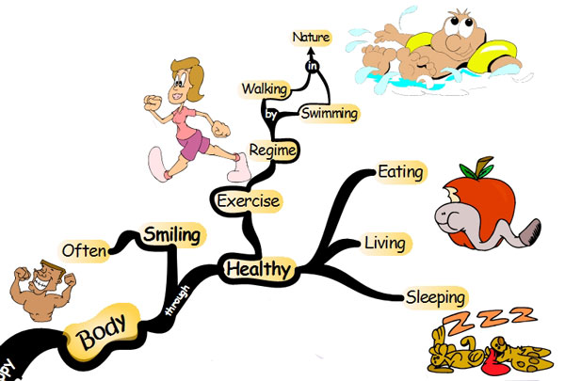
Our body is of primary importance in determining our longterm happiness. If we are healthy and feeling good about our body than we will be far more likely to be happy about other aspects of our life as well. Here are some suggestions for maintaining a happy body:

Smile Often
Smiling naturally stimulates wonderful healing chemicals within our bodies that lead to a great sense of well-being.

Exercise Regularly
Our bodies are designed to move, flex and to lift objects. If you are living a sedentary existence than your body will respond in very sluggish ways. Do you know what happens to something you don’t use? Yes, that’s right, you tend to lose it. Exercise your body regularly by swimming or even just walking in nature. Your body will no doubt thank you and be happier for it.

Healthy Eating
Our bodies also respond accordingly to the foods that we ingest and digest on a daily basis. It is said that you are what you eat. In many instances there is a lot of truth to this statement. Eat healthy living and energy giving foods, and your body will thank you in a positive way by providing you with more energy which will lead to a greater sense of happiness in your life.

Healthy Sleeping
Many of us simply do not get enough sleep. This leads to a weakening of our sensory acuity, muscles and concentration levels. On top of this our weakened state can lead to health concerns and deep feelings of tiredness and unhappiness throughout our day. Go to sleep only when you are tired and wake up at the same time every day. This will no doubt lead to much more satisfaction and happiness in your life.

Healthy Living
This is all about living a healthy life by incorporating everything discussed above into a daily routine that looks after your body from head to toe.

A Happy Mindset
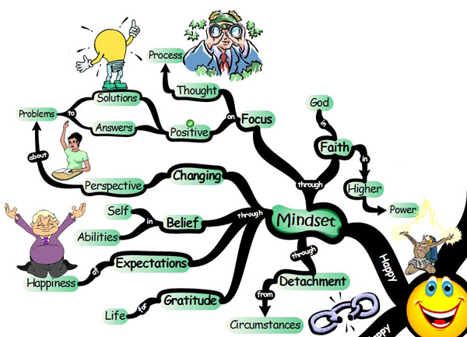
A happy frame of mind is just as important as cultivating a happy body. There are really no excuses here, as the mind is pretty much the only thing that we have full control over at every moment of our lives. Here are some suggestions on how to maintain a happy mindset:

Detachment from Circumstances
You are a human being living within your own experience. What you attach yourself emotionally to will affect your happiness in many unforeseeable ways. When you learn to detach yourself from people and circumstances you begin to take control of your life. Begin today by detaching and noticing how that makes you feel.

Faith in a Higher Power
Your faith in God or a higher power will usually get you through the toughest of times. Look up to this higher power to develop faith when evidence exists to the contrary. This faith will keep you in a state of happiness.

Positive Mental Attitude
You will achieve happiness by cultivating a positive mental attitude. This begins by paying attention to your daily thoughts and observing them carefully throughout your day. By doing this, you will begin to notice little thought habits you have and how they are making you feel in the present moment. Pick up on these shifts in your emotions immediately and change your thoughts by focusing on solutions and answers to problems and challenges that you face. These solutions and answers will keep you focused on what is good, and happiness will be the result.

Changing Perspective
This leads on from cultivating a Positive Mental Attitude. When confronted with challenges in your life, get into the habit of consciously changing your perspective about the person or situation. See the situation in a different light. Ask someone for their differing opinion and perspective. By being flexible you will move towards the path of happiness.

Belief in Self & Abilities
We have all seen instances where human beings have performed remarkable acts through the power of just their beliefs. Become one of these people. Believe in yourself and your own abilities wholeheartedly. When you set out to do something, believe that you can do it no matter what obstacles stand in your way. Belief in yourself and your own abilities will no doubt attract much happiness and joy into your life.

Expect to be Happy

It is said that, what you expect with passion will come to fruition. Expect to be happy, expect that good things will come to you, and expect that life will bring you much joy and happiness.

Gratitude for Life
You can never be truly happy unless you cultivate a sense of gratitude. Gratitude breeds life into a sad soul, and it creates abundance for those who have very little. Gratitude does not come to those who HAVE MUCH, but rather to those who are thankful for the little that is good and great in their own lives. Be grateful for the little things that you take for granted on a daily basis and your life will be filled with great happiness and joy.

Happy Interactions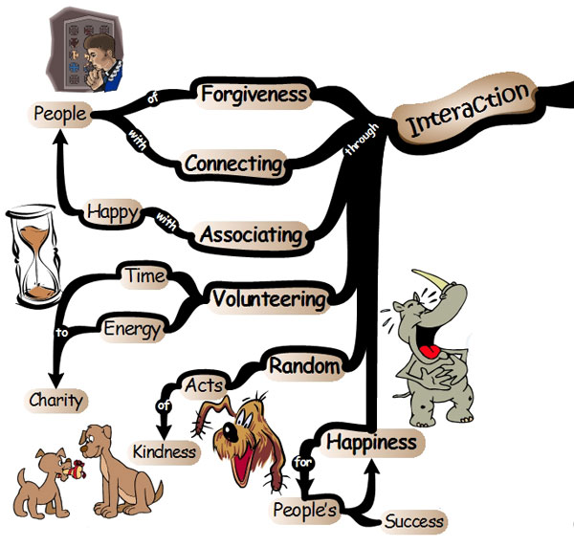
Interacting, communicating, caring for and loving others is our natural way of being. It is as natural as breathing, and yet so many of us remove ourselves from others on a daily basis, and this in turn attracts great sadness and unhappiness into our lives. Bring back a little interactivity into your life and you will experience a sense of happiness and joy like never before.
Didn’t someone once say, that “the happiness you create for others is likely to bring you more joy than anything you can do for yourself?” Whether or not someone said this or not, here are some suggestions on how to maintain happy interactions:

Forgive People
Holding onto grudges, hate and distrust will smother you with disgust and sadness. Instead, choose to leave your past in the past and move forward with your life by forgiving those who may have hurt you. Forgive and release… forgive and release… forgive and release… this will no doubt bring a sense of empowerment and happiness to a bitter existence.

Connect with People
Take time each day to connect and reconnect with others in different and creative ways. Ask others about something that brings them passion, go out and do something that you two have never done before, bring back the laughter into their life by watching a funny movie or going along to the comedy club; or simply tell them how much you love them. These simple acts will not only bring you great joy and happiness, but they will also make the other person feel very special indeed.

Associate with Happy People
It was mentioned earlier that you are what you eat. In this instance you are also very much who you associate with on a daily basis. If you are hanging around and interacting with negative people than you will be affected by their energy whether you realize it or not. Choose instead to be around happy people, around those who make you laugh and talk about positive things. This will no doubt lead to a greater sense of happiness and wellbeing.

Volunteer Time & Energy to Charity
Giving of yourself to others is no doubt the greatest gift in the world. For those who haven’t seen the 2006 movie The Ultimate Gift, I strongly suggest you see this remarkable movie to truly grasp an understanding of the effect that giving to others can have on your life. Check it out at IMDb. Give of your time and energy to others and not just your money. Money is so impersonal. By showing others that you care, will attract much happiness into your life.

Random Acts of Kindness
Doesn’t it just make you feel wonderful to know that you have helped someone in need? How much more wonderful would it feel if you took some time today to assist someone you knew needed some help in an indirect covert manner. Go ahead and help them indirectly without telling them that you were the mastermind behind this ingenious act of kindness. Getting credit for your acts of kindness is completely overrated. Knowing that you did something that other’s don’t know about, is true happiness.

Be Happy for Other’s Success
There is one moment in time, and a place, that success will find you if you keep your eyes peeled to the opportunities that lie just within your reach. If your time hasn’t come yet, it doesn’t mean that you shouldn’t be happy for another’s successes and accomplishments. Enjoy and revel in another person’s achievements. This sense of happiness you instill in them, will in turn create a reflective mirror that will encourage a greater sense of joy and fulfillment in your own life.

A Happy Self
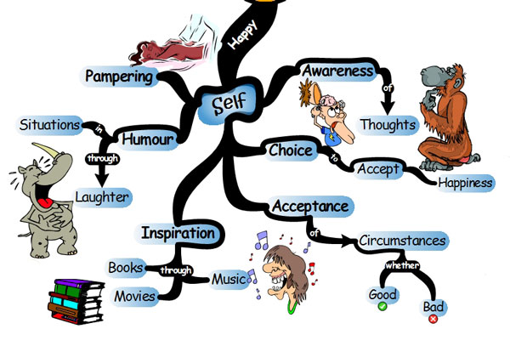
This is all about the most important person in the world, YOU. Being selfish at times and focusing on what you want most in your life is a very good way of thinking that will lead to much happiness and joy in your life. Here are some suggestions on how to maintain a happy-self:

Pamper Yourself
Take timeout each day to spend a little time with yourself. Yes, go out there and treat yourself to something special, to something sinister and a little naughty. You deserve it. Take time to pamper yourself and your days will be filled with many wonderful experiences you will treasure.

Utilize Humor
You don’t have to be the next Chris Rock, Ellen DeGeneres or Jerry Seinfeld; although if you were one of these three stand-up comedians, hanging out with you would no doubt be a great deal of fun. In all seriousness, just don’t be serious. Learn to find humor in all situations, and most importantly learn to laugh at yourself when you do something really silly that you hope no one saw!

Find Inspiration
All of us have different things that tend to inspire and motivate us on a daily basis. Identify these inspirations and cultivate them throughout your day. Whether it is a piece of music you love, a movie that just gets your juices flowing, or a book you just can’t get enough of. Take time to immerse yourself within these experiences, and you will creat more joy and happiness in your life.

Accept Circumstances
This comes down to accepting circumstances whether they are good or bad. It has been said that it is not what happens to us that determines how we feel, but rather how we perceive what happens to us. How you perceive what happens to you will determine your level of happiness. So don’t listen to the negative talkers who tell you how unlucky you were, or how unfortunate your circumstances are. Forget about them. Instead, accept the way things are, focus on solutions and move forward with a positive outlook.

Your Choice to be Happy
Do you even realize that it is your choice alone that determines whether or not you experience happiness at every moment? Well it’s true. It is your choice.
Therefore, if it is my choice, what do I choose right now?
I would choose happiness

Awareness of Thoughts
Again it is important to mention here, that you must become intricately aware of your thoughts. Notice how a single thought can either make you crumble into a state of despair, or bring you to the point of ecstasy. Yes, it is indeed your thoughts that control your emotions. Take charge of your thoughts and your emotions will be on top of the world.

Happy Actions 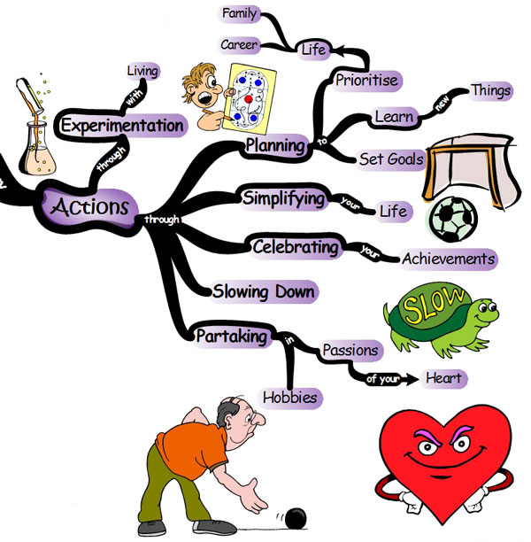
What you do with what you have on a daily basis will no doubt effect your levels of happiness. In fact, everything that has been discussed so far up to this point effects the actions you will take in profound ways. If you are not happy and living in a state of deep sadness, what kind of actions do you think are likely to result from these types of emotions? I wouldn’t say they would be very effective. However, having said that, your actions alone can indeed add great happiness, depth and joy to your life. Here are some suggestions on how to maintain and cultivate happy actions:

Experiment with Living
This doesn’t mean taking drugs or picking up the habit of smoking and all those other things that will make you very unhappy longterm. Instead this means simply adding some variety and creativity into your life. Take time to do something you haven’t done before. In fact, what is one thing that you wish you could do but haven’t yet tried? Okay, now go ahead and make a decision to get up right now, tonight or tomorrow, and just do it. Just go crazy, have fun, live a life full of excitement and be unpredictable. Happiness will surely follow a person who lives in such a manner.

Plan Your Life
It’s okay to be spontaneous and to live on the edge at times, however, it is also important to think about your longterm future and ongoing happiness. Therefore spend time each week planning your career and family life in ways that will add more happiness and joy to your daily routines. Plan also to learn new things that will move you forward in your career or potentially open up new doors of opportunity. Plan also to set goals, and then actually sit down and set them, and over time make the necessary steps to accomplish them within the time frames you set.
It is no accident that we have reached such breathtaking technological advancements because we as a human race have been setting many goals over many, many generations. You are part of this human race, are you not? Than set some goals today and go move into action already! The accomplishment of a passionate goal coming to fruition will bring you much joy and happiness.

Simplify Your Life
So many of us go through life over complicating matters. We do something the long way around. We take the long and difficult path and struggle with too much clutter, too many responsibilities and too many headaches. Take time today to simplify your life and happiness will surely follow. Think Simple Now is a great blog about this very concept that I would highly recommend.

Celebrate Your Achievements
First you have to achieve, this requires setting goals and acting on them. But then again, have a think about the little things, the little achievements you experience on a weekly basis. Reward yourself occasionally by celebrating these little things. Afterwards be sure to raise the bar to even higher standards of achievement and celebrate your success once you have reached these targets.
Celebrating is fun, and will bring great joy and happiness into your life. However, be warned, not to overdo it. Your celebrations should be rewards for your accomplishments, and not your Friday and Saturday night routine. Start simple and small, then progress onwards to bigger goals and greater rewards.

Slow Down
S…L…O…W… D…O…W…N…
That’s it…
Be consciously aware of slowing down and not being so caught up in the frantic aftermath of your daily existence. Happiness follows those who slow down, reflect, ponder and think. Your decision making may also dramatically improve.

Partake in Your Passions
First, do what you love and keep on doing it at every opportunity you get. Secondly, ask yourself if you can somehow make a living from doing what you love. Happiness comes to those who live with a passion. Are you living out your passions or wishing for better days?

Avoid Unhappiness
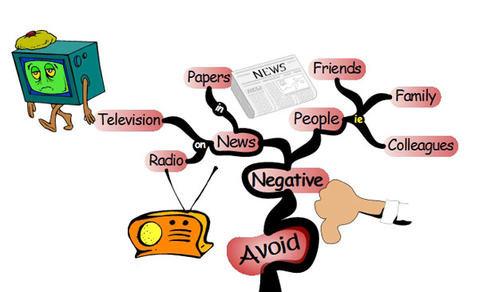
Cultivate everything that has been discussed thus far on a daily basis and you will be living a life full of joy and happiness. On the other hand, be aware of a couple of things that may get you down and lead to emotions that you would like to leave in the trashcan.

Avoid Negative People
You will ALWAYS tend to reflect the emotions of the people you associate with most often. If you don’t believe this statement, than take a good long hard look at a group of people who know each other well, and you find that they all tend to experience similar types of emotional levels throughout their daily lives. You are a reflection of other people’s emotional peaks and valleys. Take charge of your life by avoiding those people who bring you down into the doldrums of emotional hardship.

Avoid Negative News
This is a difficult one, especially if you are hanging around with a group of NEGATIVE PEOPLE who always talk about their problems and put the most negative twists on anything they hear on television or radio. This does not mean that you should be ignorant, all it means is that you moderate your intake of negative news. Simply don’t dwell on it. If you can’t do something about this news in your immediate moment, than simply direct your attention elsewhere. Be and stay in control and happiness will always find you.

Final Thoughts
As you can see, happiness is very easy to obtain if you know how to find it. I hope that this reflection has been helpful in assisting you to find more happiness in your life. If you have any further thoughts, ideas, reflections and suggestions on this topic than by all means please feel free to add to this. It is just the starting point..

