'Different' dolls have same purpose
By Julia McKay, Kingston Whig-Standard
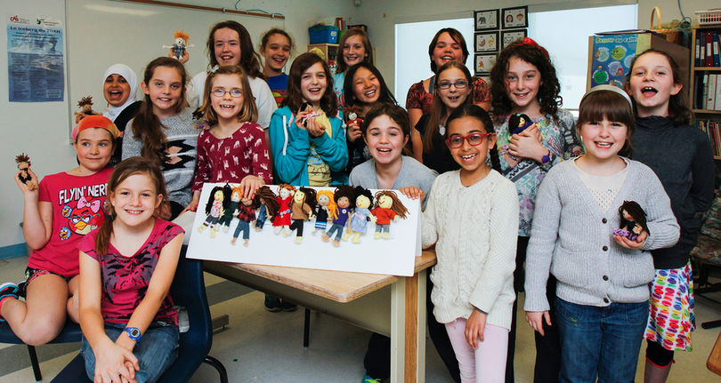
Sunday, April 19, 2015 7:33:18 EDT PM
Students with the Humanitarian Club at Madeleine-de-Roybon Ecole Elementary Publique pose for a group photo with their special yarn dolls in Kingston, Ont. on Tuesday April 14, 2015. The grade four and five students have made 140 Pocket Buddies//Ami(e)s de Poche that will be given to children in the Republic of Congo and Kenya. Julia McKay/The Kingston Whig-Standard/Postmedia Network
Seemingly small things can help make a big difference in the life of an underprivileged child.
By wrapping, tying up and braiding coloured yarn, local elementary students have been able to create pocket-sized dolls called Pocket Buddies.
Every Friday, the group of grade 4 to 6 students volunteer to meet, as part of the Humanitarian Club at Madeleine-de-Roybon Ecole Elementaire Publique, to make yarn dolls.
The idea started with Grade 2 teacher Jacynthe Aubut, after having worked on a rainbow bracelet project last year.
"It was (started) to teach kids about making something to give and not expecting anything back," Aubut said. "I find that some kids don't have that concept that we have a lot and other people in other countries don't have anything."
Since November 2014, students in the club have made more than 140 pocket buddies, with the goal of giving them to children in less fortunate countries.
Each doll is unique, with the student having free rein to choose colours and sizes.
Some dolls have dark skin while others have light. Some are petite and others have unique hair.
"Every one's different because no one is the same. That's what makes you unique and that's what makes these dolls unique," Taylor Belisle, Grade 5 club member said. "It feels good because we're helping other people."
Aubut has been surprised to see the amount of creativity and attention to detail the students put into each doll.
"They're very personalized toys as well," Aubut said. "(The students) give a personality to their dolls, and I find that it's a really cherished moment. They wanted to say goodbye (to the dolls)."
"After you're done you can decide if it's a boy or a girl (doll), because you can cut their hair or basically decide anything you want with the doll," Alexandra Lee, another club member, said "It's an act to help people who don't have much and they can just let their imagination go wild with these dolls that we made. It's a good feeling."
The students are able to make approximately one pocket buddy each week.
"They might work for a total of 30 minutes each time," Aubut said. "Some (students) are faster than others. I will say, on average, they make one complete doll every time we meet."
The club helps the students learn about teamwork while getting to spend time with their friends.
"They come for fun and friendship; they come because they care," Aubut said.
"It makes me feel good because I know that what I made is going to help someone have fun and have a smile on their face," Marijane Drapeau, club member, said. "It makes me feel happy."
Next, the pocket buddies will be heading to the Democratic Republic of Congo, with local artist Heather Haynes, this month and with another bunch going to Kenya with Nancy Stevens in September.
"I think this could be the first toy that some are going to touch," Eve Morneau, club member, said. "I think (other kids) are going to be happy and they're going to have more toys to play with."
In addition to the dolls, Aubut has received help from fellow teachers and parents in making clothes for each pocket buddy.
"I am so thankful from all of the help we got from parent volunteers and colleagues at school," Aubut said. "The success of this project would have been a lot more challenging without them."
Aubut is now looking closer to home at ways of providing the dolls to children in need in the local community.
"It's fun, but also they love them and they know that it's going to make the other children happy," Aubut said.
julia.mckay@sunmedia.ca Twitter.com/JMcKayPhoto
